

Allotment - User Stories & Wireframes

Contents
Changes 4
User Stories- Allotment Process 4
1. User Story- Add Application Details 4
1.1 Mock-ups 8
2. User Story- Edit Application Details 11
2.1 Mock-ups 14
3. User Story- View Application Details 16
3.1 Mock-ups 18
4. User Story- Add Bulk Application Entries 18
4.1 Mock-ups 20
5. User Story- Allotment of Property 21
5.1 Mock-ups 24
6. User Story- Edit Allotted Property 25
6.1 Mock-ups 28
7. User Story- View Allotted Property 29
7.1 Mock-ups 32
8. User Story- Add Bulk Allotment Entries 32
8.1 Mock-ups 34
9. User Story- Create Allottee List of a scheme 35
9.1 Mock-ups 36
10. User Story- View Allottee List 37
10.1 Mock-ups 39
11. User Story- Submit Allottee list for approval 40
11.1 Mock-ups 41
12. User Story- View Comment 41
12.1 Mock-ups 42
13. User Story- Generate Bulk Allotment Letter 43
13.1 Mock-ups 44
14. User Story- Generate Bulk Payment Schedule 44
14.1 Mock-ups 47
15. User Story- Generate Bulk Allotment Money Challan 47
15.1 Mock-ups 48
16. User Story- Generate an Allotment Letter 48
16.1 Mock-ups 50
17. User Story- Generate a Payment Schedule 51
17.1 Mock-ups 54
18. User Story- Generate an Allotment Money Challan 55
18.1 Mock-ups 56
19. User Story- Create unsuccessful applicant list 57
19.1 Mock-ups 58
20. User Story- View Unsuccessful Applicant List 58
20.1 Mock-ups 60
21. User Story- Submit unsuccessful candidate list for approval 61
21.1 Mock-ups 62
22. User Story- Initiate Refund for Unsuccessful Applicants 62
22.1 Mock-ups 63
23. User Story- Approve/Reject request 63
23.1 Mock-ups 64
24. User Story- View Allottee List for approver 65
24.1 Mock-ups 66
25. User Story- View Unsuccessful Applicant list for approver 67
25.1 Mock-ups 68
26. User Story- View Comment 68
26.1 Mock-ups 69
27. User Story- Update Personal Information 70
27.1 Mock-ups 71

Changes
S NO | MODULE | DESCRIPTION | Date
1 | 1 | Updated validations in user stories and department name in manage allotment grid (Mockup updated) | 04/07/2016
2 | All | Mockups updated | 23/06/2016
3 | 3 | Removed payment option via challan | 23/06/2016
5 | 23 | Payment Schedule Trigger | 23/06/2016
6 | 8 | User story on hold as per dev team request | 23/06/2016
7 | 12,19,20,21,22,26 | Changed Refund to ‘Refund for Unsuccessful Applicants’ | 23/06/2016
8 | 14, 17 | Excel attached for payment schedule calculation | 21/06/2016
9 | All | Mockups Updated | 21/06/2016
10 | 1, 2 | Updated Acceptance Criteria | 08/06/2016
11 | 1.1,1.2 | Mockups for RTGS payment updated | 08/06/2016
12 | 27 | Business Rules and Acceptance criteria updated | 08/06/2016
13 | 27.1 | Mockup updated | 08/06/2016
14 | 1.1,2.1 | Mockups Updated | 06/06/2016
15 | 26.1,27.1 | Mockups Updated | 06/06/2016
16 | 11.1,12.1 | Mockups Updated | 06/06/2016
17 | 26 | Updated business rules | 06/06/2016
18 | 23 | Updated business rules | 06/06/2016
19 | 5 | Updated business rules | 06/06/2016
20 | 6 | Updated business rules | 06/06/2016
21 | 8 | Updated business rules | 06/06/2016
22 | 10 | Updated business rules | 06/06/2016
23 | 10.1 | Updated Mockups | 06/06/2016
24 | 20 | Updated business rules | 06/06/2016
25 | 20.1 | Updated Mockups | 06/06/2016

User Stories- Allotment Process

User Story- Add Application Details

Sprint | 3
User Story ID | 001
User Story Title | Add Applicant Details
Actors | Department user
Story | As a department user, I want to add application details into the system for allotment of property.
Pre Conditions | - User should have required access rights.
Business Criteria | - Form number would be unique scheme wise and within a department.  - In case of Company as gender these fields should not be visible:  - Father’s Name  - Mother’s Name  - Date of Birth  - Marital status  These fields Should be visible:  - Signing Authority  - Registered Office
Acceptance Criteria | - User would click on ‘Add application details’ button under manage applicant menu.  - User would get a form with the following fields:  Accordion 1: Personal Information  - Scheme Name: dropdown, mandatory  - Department: dropdown, mandatory  - Form Number: Textbox, mandatory  - First Name: Textbox, mandatory  - Middle Name: Textbox  - Last Name: Textbox, mandatory  - Gender: Dropdown (values: male, female, and company), mandatory  - Marital Status: Dropdown (values: married, Unmarried)  - Father’s Name: Textbox ( male, unmarried female)/ Husband’ Name (married females), mandatory, default ‘NA’  - Mother’s name: Textbox, mandatory, default ‘NA’  - Date of Birth: Date picker, Mandatory (disabled in case of company as gender)  - Signing Authority: Textbox, mandatory (visible in case of Company as gender)  - Registered Office: Textbox, mandatory (visible in case of Company as gender)  - Email: Textbox, optional  - Permanent Address: Textbox, mandatory  - Correspondence Address: Textbox, mandatory  - Mobile Number: Textbox (numeric), mandatory  - Phone Number: Textbox (part1: STD, part2: number)  - FAX number: Textbox (part1: STD , part2: number)  - Occupation: Dropdown (values: Self-employed, Private Employee, Govt. Employee, Farmer, Pensioner), mandatory  - Quota Category: Dropdown, mandatory  - Religion: Dropdown, mandatory  - PAN Number: Textbox, mandatory  - Annual Income: Textbox, mandatory  Accordion 2: Payment Information  User would select the required payment option from the three options available viz. Demand Draft, RTGS, Challan. Based on the selection, following fields would be displayed:  For Demand Draft:  - Amount Deposited: Dropdown, mandatory (Group wise Earnest Money of a scheme)  - Bank Name: Dropdown, mandatory  - Branch Address: Dropdown, mandatory  - Demand Draft number: Textbox, mandatory  - Issue Date: Date picker, mandatory  - Issue Bank: Textbox  For RTGS:  - Amount Deposited: Textbox, mandatory  - Bank Name: Dropdown, mandatory  - UTN: Textbox, mandatory  - Date  - After filling the form, user would click on submit button to add application detail or alternatively, user would click on ’Cancel’ button to return to the ‘Manage Application’ screen.  - Once user successfully added an application details it would be displayed in a grid on manage application screen with following columns:  - Scheme Name  - Department  - Form Number  - Mobile Number  - Actions: ‘View’, ‘Edit’.
Field level Validation | - Form No: Numeric, maximum 15 digits.  - First Name: Text with no numbers and special characters, Maximum 100 characters.  - Middle Name: Text with no numeric and alphabets, Maximum 100 characters.  - Last Name: Text with no numeric and alphabets, Maximum 100 characters.  - Father’s/Husband’s Name: Text with no numbers, only space as special character, Maximum 150 characters.  - Mother’s Name: Text with no numbers, only space as special character, Maximum 150 characters.  - Signing Authority: Text with no numbers, only space as special character, Maximum 150 characters.  - Email: Text with numbers and special characters, maximum 100 characters, validate against email format(abc@xyz.com)  - Registered Office: Text with numbers and special characters, maximum 500 characters.  - Date of Birth: Check Age, it should be minimum 18 years at the time of filling application.  - Permanent Address: Text with numbers and special characters, maximum 500 characters.  - Correspondence Address: Text with numbers and special characters, maximum 500 characters.  - Mobile Number:  Numeric, fixed 12 digits, can’t be zero  - Phone Number:  - Part 1: numeric, maximum 8 digits, can’t be zero  - Part 2: numeric, maximum 12 digits, minimum 8 digits, can’t be zero  - FAX Number:  - Part 1: numeric, maximum 8 digits, can’t be zero  - Part 2: numeric, maximum 12 digits, minimum 8 digits, can’t be zero  - PAN Number: Alphanumeric with no special characters, fixed 10 digits, can’t be zero  - Annual Income: Numeric, maximum 15 digits, heck for minimum amount i.e., INR 50000  - Demand Draft Number: Alphanumeric, maximum 6 characters  - Challan Number: Numeric, maximum 20 digits, can’t be zero  - Issue Bank: Text with only space as special characters, no numbers, maximum 50 characters.

Mock-ups

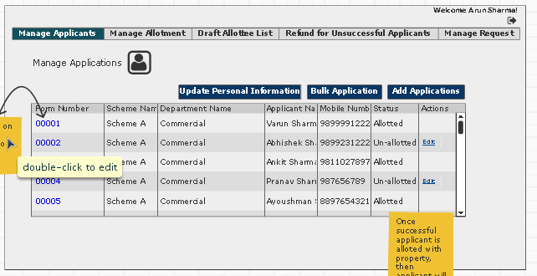

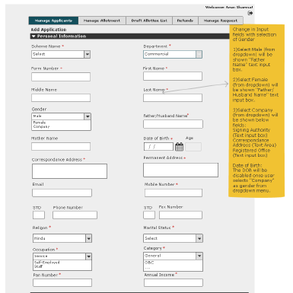
Part 1 Applicant details
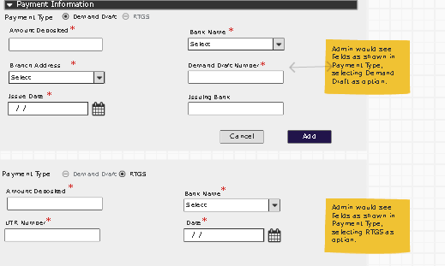
Part 2 payment details

User Story- Edit Application Details

Sprint | 3
User Story ID | 002
User Story Title | Edit Application Details
Actors | Department user
Story | As a department user, I want to edit application details.
Pre Conditions | - User should have required access rights.
Business Criteria | - Application details cannot be edited, once a property is allotted to the applicant.  - Form number would be unique scheme wise and within a department.  - In case of Company as gender these fields should not be visible:  - Father’s Name  - Mother’s Name  - Date of Birth  - Marital status  These fields Should be visible:  - Signing Authority  - Registered Office
Acceptance Criteria | - User would click on ‘Edit’ option from the set of options available in grid against each Application added.  - User would get a pre filled form with the following fields:  Accordion 1: Personal Information  - Scheme Name: dropdown, mandatory  - Department: Disabled dropdown, mandatory (prefilled as per department login)  - Form No: Textbox, mandatory  - First Name: Textbox, mandatory  - Middle Name: Textbox  - Last Name: Textbox, mandatory  - Gender: Dropdown (values: male, female, and company), mandatory  - Marital Status: Dropdown (values: married, Unmarried)  - Father’s Name: Textbox ( male, unmarried female)/ Husband’ Name (married females), mandatory, default ‘NA’  - Mother’s name: Textbox, mandatory, default ‘NA’  - Date of Birth: Date picker, Mandatory (disabled in case of company as gender)  - Signing Authority: Textbox, mandatory (visible in case of Company as gender)  - Registered Office: Textbox, mandatory (visible in case of Company as gender)  - Email: Textbox, optional  - Permanent Address: Textbox, mandatory  - Correspondence Address: Textbox, mandatory  - Mobile Number: Textbox (Numeric), mandatory  - Phone Number: Textbox (part1: STD code, part2: number)  - FAX number: Textbox (part1: STD code, part2: number)  - Occupation: Dropdown (values: Self-employed, Private Employee, Govt. Employee, Farmer, Pensioner), mandatory  - Quota Category: Dropdown, mandatory  Accordion 2: Payment Information  User would select the required payment option from the three options available viz. Demand Draft, RTGS, Challan. Based on the selection, following fields would be displayed:  For Demand Draft:  - Amount Deposited: Dropdown, mandatory (Group wise Earnest Money of a scheme)  - Bank Name: Dropdown, mandatory  - Branch Address: Dropdown, mandatory  - Demand Draft number: Textbox, mandatory  - Issue Date: Date picker, mandatory  - Issue Bank: Textbox  For RTGS:  - Amount Deposited: Textbox, mandatory  - Bank Name: Dropdown, mandatory  - UTN: Textbox, mandatory  - Date  - After updating the form, user would click on submit button to update application details successfully or alternatively, user would click on ’Cancel’ button to return to the ‘Manage Application’ screen without making any changes.
Field level Validation | - Form No: Numeric, maximum 15 digits.  - First Name: Text with no numbers and special characters, Maximum 100 characters.  - Middle Name: Text with no numeric and alphabets, Maximum 100 characters.  - Last Name: Text with no numeric and alphabets, Maximum 100 characters.  - Gender: Dropdown (values: male, female, and company), mandatory  - Marital Status: Dropdown (values: married, Unmarried)  - Father’s Name: Textbox ( male, unmarried female)/ Husband’ Name (married females), mandatory, default ‘NA’  - Mother’s name: Textbox, mandatory, default ‘NA’  - Date of Birth: Date picker, Mandatory (disabled in case of company as gender)  - Signing Authority: Text with no numbers, only space as special character, Maximum 150 characters.  - Registered Office: Text with numbers and special characters, maximum 500 characters.  - Email: Text with numbers and special characters, maximum 100 characters, validate against email format(abc@xyz.com)  - Permanent Address: Text with numbers and special characters, maximum 500 characters.  - Correspondence Address: Text with numbers and special characters, maximum 500 characters.  - Mobile Number:  Numeric, maximum 12 digits, can’t be zero  - Part 2: numeric, fixed 10 digits, can’t be zero  - Phone Number:  - Part 1: numeric, maximum 8 digits, can’t be zero  - Part 2: numeric, maximum 12 digits, minimum 8 digits, can’t be zero  - FAX Number:  - Part 1: numeric, maximum 8 digits, can’t be zero  - Part 2: numeric, maximum 12 digits, minimum 8 digits, can’t be zero  - Demand Draft Number: Alphanumeric, maximum 6 characters  - Challan Number: Numeric, maximum 20 digits, can’t be zero  - Issue Bank: Text with only space as special characters, no numbers, maximum 50 characters.

2.1 Mock-ups

Part 1 Applicant details
Part 2 payment details

User Story- View Application Details

Sprint | 3
User Story ID | 003
User Story Title | View Application Details
Actors | Department user
Story | As a department user, I want to view application details.
Pre Conditions | - User should have required access rights.
Business Criteria | - In case of Company as gender these fields should not be visible:  - Father’s Name  - Mother’s Name  - Date of Birth  - Marital status  These fields Should be visible:  - Signing Authority  - Registered Office
Acceptance Criteria | - User would click on form no available in grid against each application added.  - User would get complete details of the applicant:  Accordion 1: Personal Information  - Scheme Name  - Department  - Form No  - First Name  - Middle Name  - Last Name  - Gender  - Signing Authority  - Registered Office  - Permanent Address  - Correspondence Address  - Mobile Number  - Phone Number  - FAX number  - Occupation  - Quota Category  Accordion 2: Payment Information  If payment using Demand Draft:  - Amount Deposited  - Bank Name  - Branch Name  - Demand Draft number  - Issue Date  - Issue Bank  If payment using RTGS:  - Amount Deposited  - Bank Name  - UTN
Field level Validation

Mock-ups

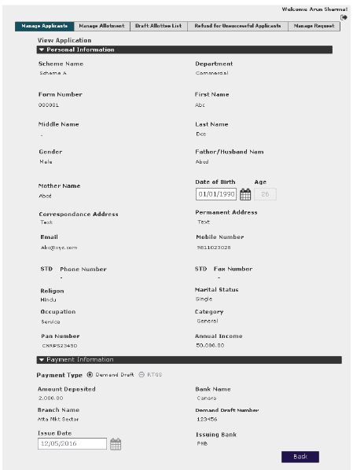

User Story- Add Bulk Application Entries

Sprint | 3
User Story ID | 004
User Story Title | Add bulk Application Entries
Actors | Department user
Story | As a department user, I want to bulk upload applications for allotment
Pre Conditions | - User should have required access rights.
Business Criteria | - Form number would be unique scheme wise and within a department.  - Only excel file can be uploaded, strictly check for format.  - Excel format should contain all fields of Application entry form (for all scenarios) except scheme name and department name. This will be same for all entries in the format, as selected while downloading/uploading format.
Acceptance Criteria | - User would click on ‘Bulk Application’ button under manage applications screen.  - User would get a window popup with  - Step 1: Download Format  User would select scheme name and department (based on scheme) from dropdown. User would click on ‘download format’ button and an excel file would be downloaded to local system with a prescribed format, fixed scheme name and department name. User would click on ‘Next’ button to proceed to next step  - Step 2: Upload file  User would browse to the file with applications data to be uploaded. User would click on ‘Upload’ button to upload data or alternatively user would click on ‘Back’ button to go back to previous page.  Once user click on ‘Upload’ button, a progress bar will be displayed which show the progress of data being uploaded. Once progress completes to hundred percent user would click on ‘Finish’ button to complete the process.  - Flow would return to manage applicant screen and all uploaded entries would be displayed in the grid with following columns:  - Scheme Name  - Department  - Form Number  - Mobile Number  - Actions: ‘View’, ‘Edit’
Field level Validation | - Only excel file would be uploaded.

Mock-ups

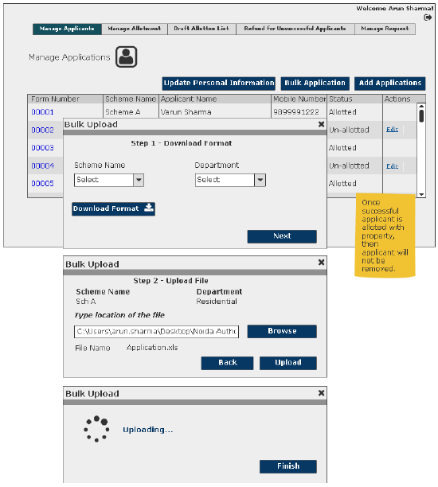

User Story- Allotment of Property

Sprint | 3
User Story ID | 005
User Story Title | Allotment of Property
Actors | Department user
Story | As a department user, I want to allot a property to a successful applicant.
Pre Conditions | - User should have required access rights.
Business Criteria | - Once an applicant is being allotted with a property then, the applicant would not be available for further allotment in the same department within a scheme.  - Once payment for a property/allottee is refunded, then Allottee would not be available for allotment for the same scheme.  - Once a property is allotted to an applicant, an RID is generated for the applicant.  - Scheme would be visible department wise. For a particular department only those schemes would be visible for allotment which includes the respective department.  - Within scheme,  - Department wise property should be visible for allotment.  - Allotted property should not be visible for allotment.  - Property Number would be in a format (sector/block-property number e.g., 12/A-123)  - Instalment Date: Allotment Date + Frequency (in months)  - Allotment Money Due Date = Allotment Date + 30 days  - In case change in area, the same would be updated to master table  - In case of change in area (for departments other than housing), total property cost would be revised and updated.  - System will calculate Total Property Cost, Effective Property Cost, Earnest Money, and Allotment Money.  calculation for total property cost(Department Other than Housing)  Property Cost for a given scheme is calculated on the basis of total area and the rate of allotment for the area. Below is the relation to calculate the Property Cost.  Total Property Cost = (AR * Rate) (In case of housing property cost will not be calculated, direct data entry)  Where,  AR = Total Area (Sq. Mt.)  Rate = Land rate (per square meter, vary as per schemes)  Calculation of Allotment Money (Department Other than Housing)  Allotment money is calculated using below relation  Allotment Money = (Property Cost * Q)/100)  Where,  Q = Defined percentage of the Property Cost  Note: - Allotment Money includes Earnest money.
Acceptance Criteria | - User would click on ‘Add allotment’ button under ‘Manage Allotment’ menu.  - User would get a form vertically divided in two parts:  - Applicant Details  - Property Details  User would first select scheme name from the dropdown then , user needs to select Form no. from Application details part which would display the following information:  - Applicant Name: Label  - Gender: Label  - Father’s Name (Male, unmarried female)/Husband’s Name (married female).  - Mother’s Name  - Mobile Number  - Address  - Earnest Money  Against every Application entry User would select property no. to be allotted from property details part which would display following information:  - Block  - Sector  - Property Type  - Floor (In case of Housing Flats)  - Area Range (In case of industrial And institutional property)  - Area (sq. mtr.): Textbox, editable (auto populated based on scheme master data)  - Total Property Cost  - Civil Cost  - No of Installment  - Allotment Money: Label  - Allotment Date: Date Picker, to be filled  - Installment Date: Date Picker, editable (auto calculated based on frequency of installments in master data)  - User would click on ‘Submit’ button to allot a property to an applicant which would be displayed in a grid on ‘manage Allotment’. Alternatively, user would click on ‘Cancel’ button to return to ‘manage allotment’ screen without making any changes.  - Grid will contain following columns:  - RID  - Scheme Name  - Department Name  - Property Number, Format: Sector/Block-number  - Applicant Name  - Allotment Date  - Status (Approved/In Progress)  - Actions: ‘View’, ‘Edit’
Field level Validation | - Area: Textbox, Decimal (15,2), can’t be zero

Mock-ups

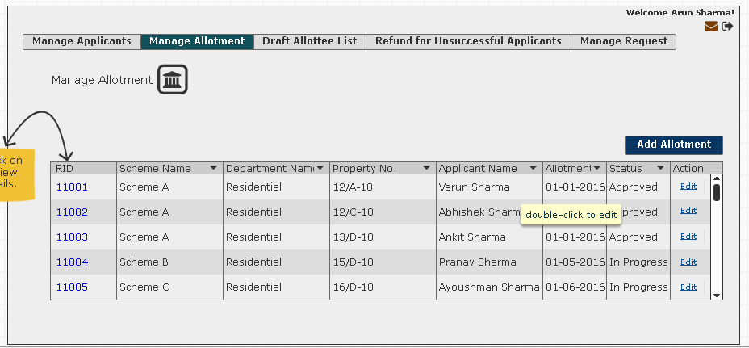
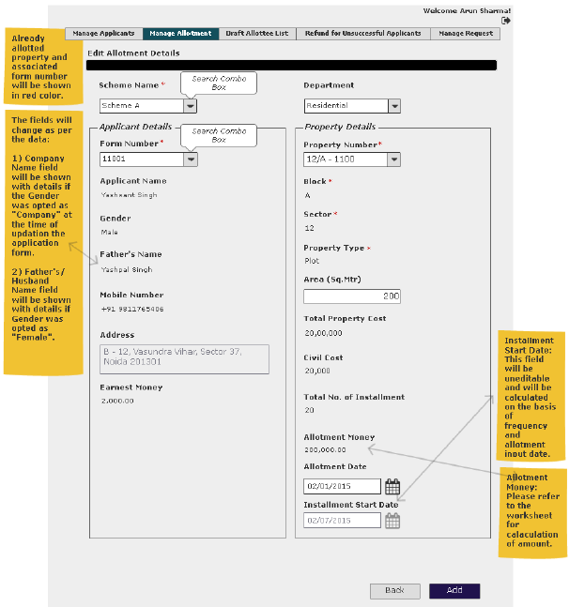

User Story- Edit Allotted Property

Sprint | 3
User Story ID | 006
User Story Title | Edit Allotted Property
Actors | Department user
Story | As a department user, I want to edit an allotted property.
Pre Conditions | - User should have required access rights.
Business Criteria | - Once allotted property is approved it cannot be edited.  - Once an applicant is being allotted with a property then, the applicant would not be available for further allotment in the same department within a scheme.  - Once payment for a property/allottee is refunded, then it would not be available for allotment.  - Once a property is allotted to an applicant an RID is generated for the applicant.  - In case change in area, the same would be updated to master table  - In case of change in area (for departments other than housing), total property cost would be revised and updated as per the formula (later in this section).  - Scheme should be visible department wise. For a particular department only those schemes should be visible for allotment which includes the respective department.  Within scheme,  - Property Number would be in a format (sector/block-property number e.g., 12/A-123)  - Department wise property should be visible for allotment.  - Allotted property should not be visible for allotment.  - Instalment Date: Allotment Date + Frequency (in months)  - Allotment Money Due Date = Allotment Date + 30 days  - System will calculate Total Property Cost, Effective Property Cost, Earnest Money, and Allotment Money.  calculation for total property cost(Department Other than Housing)  Property Cost for a given scheme is calculated on the basis of total area and the rate of allotment for the area. Below is the relation to calculate the Property Cost.  Total Property Cost = (AR * Rate) (In case of housing property cost will not be calculated, direct data entry)  Where,  AR = Total Area (Sq. Mt.)  Rate = Land rate (per square meter, vary as per schemes)  calculation of Effective Property cost  Effective property cost is property cost in addition with location charges.  Calculation of Allotment Money (Department Other than Housing)  Allotment money is calculated using below relation  Allotment Money = (Property Cost * Q)/100)  Where,  Q = Defined percentage of the Property Cost  Note: - Allotment Money includes Earnest money.
Acceptance Criteria | - User would click on ‘Edit’ option from the set of options available in grid against each Allotment added.  - User would get same form vertically divided in two parts:  - Applicant Details  - Property Details  Application details part which would display the following information:  - RID  - Applicant Name: Label  - Gender: Label  - Father’s Name (Male, unmarried female)/Husband’s Name (married female).  - Mother’s Name  - Mobile Number  - Address  - Earnest Money  Property details part which would display following information:  - Block  - Sector  - Property Type  - Floor(In case of Housing Flats)  - Area Range (In case of industrial And institutional property)  - Area (sq. mtr.): Textbox, editable (auto populated based on scheme master data)  - Total Property Cost  - Civil Cost  - No of Installment  - Allotment Money: Label  - Allotment Date: Date Picker, to be filled  - Installment Date: Date Picker, editable (auto calculated based on frequency of installments in master data)  - User would edit the information and click on ‘Submit’ button to edit allotment of a property to an applicant. Alternatively, user would click on ‘Cancel’ button to return to ‘manage allotment’ screen without making any changes.
Field level Validation | - Area: Textbox, Decimal(15,2), can’t be zero  - Allotment date: Doesn’t include Sundays

Mock-ups
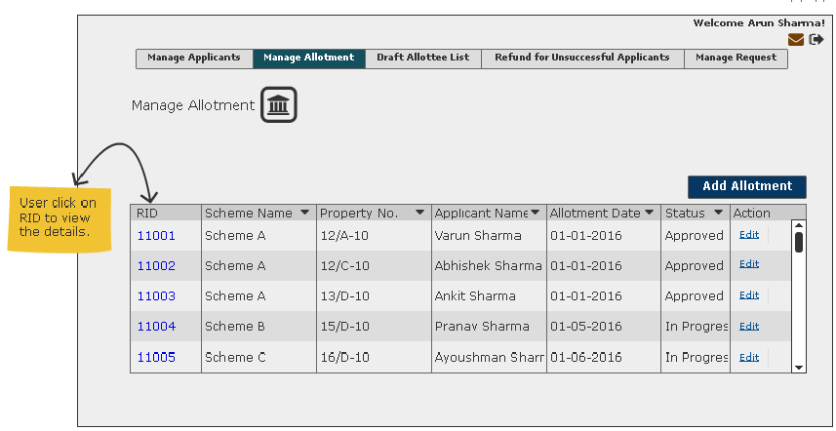
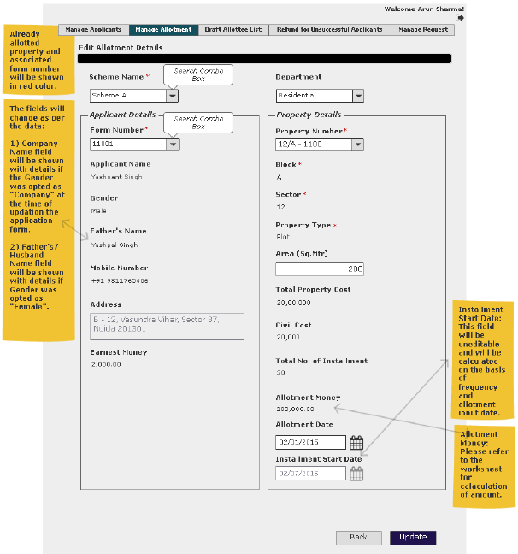

User Story- View Allotted Property

Sprint | 3
User Story ID | 007
User Story Title | View Allotted Property
Actors | Department user
Story | As a department user, I want to view an allotted property.
Pre Conditions | - User should have required access rights.
Business Criteria | - Allotment Money Due Date = Allotment Date + 30 days ( configurable)
Acceptance Criteria | - User would click on RID available in grid against each Allotment added.  - User would get a screen with complete allotment information of an allotted property. Screen will contain Scheme name and department at the top and then the information is divided into sections.  Applicant details  - Form Number  - Applicant name  - Gender  - Father’s Name  - Mobile Number  Correspondence Address  - Occupation  - Category  - Religion  - Annual Income  - PAN Details  Applicant Payment Details  For Demand Draft:  - Amount Deposited  - Bank Name  - Branch Name  - Demand Draft number  - Issue Date  - Issue Bank  For RTGS:  - Amount Deposited  - Bank Name  - UTN (Unique Transaction Number)  Allotted Property Details  - RID  - Property Number  - Block  - Sector  - Property Type  - Area (Sq. Mtr.)  - Total Property Cost  - Civil Cost  - No of Installment  - Allotment Money  - Allotment Date  - Installment Start Date
Field level Validation

Mock-ups

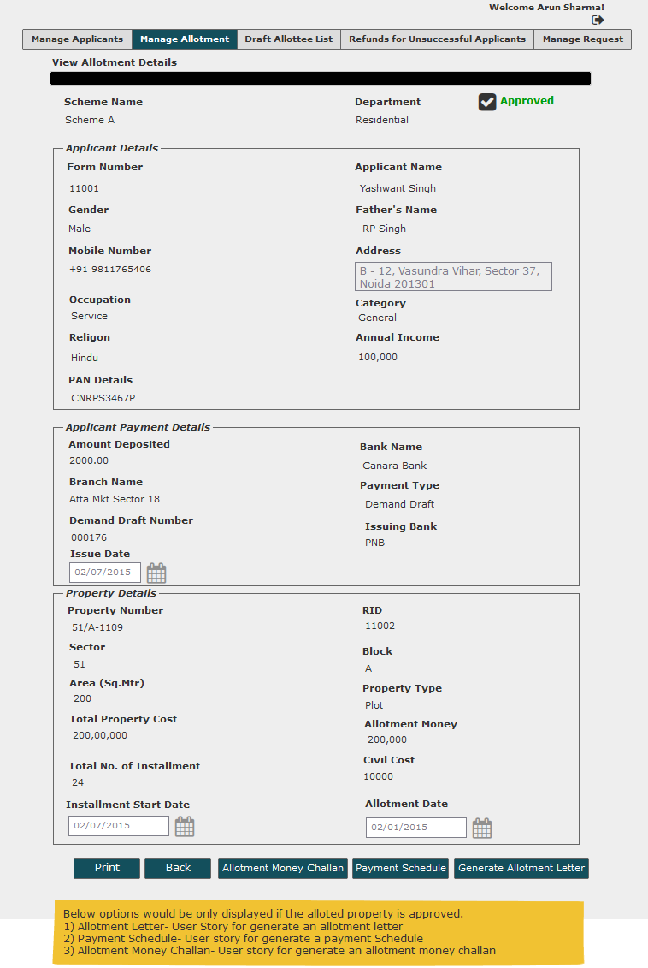

User Story- Create Allottee List of a scheme

Sprint | 3
User Story ID | 009
User Story Title | Create Allottee List of a scheme
Actors | Department user
Story | As a department user, I want system to create allottee list of a scheme based on allotment details.
Pre Conditions | - User should have required access rights.
Business Criteria | - Allottee list would be created by system based on allotment entry.  - Allottee list should be visible department wise for each scheme, user can only see entries for his departments
Acceptance Criteria | - User would click on ‘Draft allottee list’ and get a grid which contain scheme wise allottee list details, this will be created by system, based on the approved allotment entry data. For each allottee list, grid will contain following columns:  - Scheme Name  - Department  - Status, Values (approved, in progress, not submitted, Rejected)  - Submitted Date (blank if not submitted)  - Allotment Date (only approved entries approved)  - Actions- ‘View List’.
Field level Validation

Mock-ups

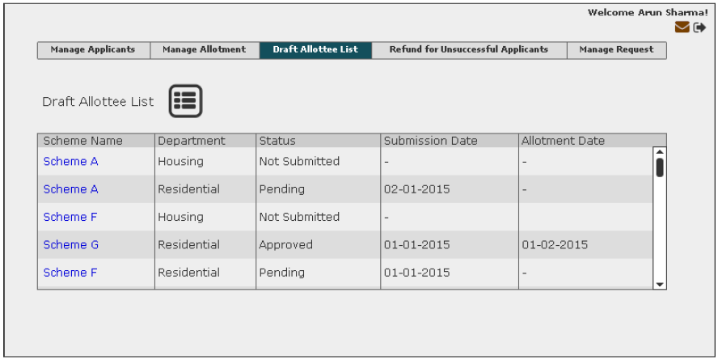

User Story- View Allottee List

Sprint | 3
User Story ID | 010
User Story Title | View Allottee Lists
Actors | Department user
Story | As a department user, I want to view allottee list.
Pre Conditions | - User should have required access rights.
Business Criteria | - Allottee list should be visible department wise for each scheme, user can only see entries for his departments  - Allotment Money Due Date = Allotment Date + 30 days  - If allottee list is not submitted, user would get ‘Submit for approval’ button along with ‘Print’ and ‘Close’ button  - If allottee list is submitted for approval but not approved yet user would get ‘Submit for Approval’ button grayed out along with ‘print’ and ‘close’ button.  - If allottee list is approved then, user would get following buttons:  - Bulk Allotment Money Challan  - Bulk Payment Schedule  - Bulk Allotment Letter  - View Comment  - Print  - Close  - If Allottee list is rejected then, user would get ‘Submit for Approval’ button along with ‘View Comment’, ‘Print’ and ‘Close’ buttons.
Acceptance Criteria | Navigation: Draft Allottee List -> View List  - User would get the allottee list for each department within scheme, with the following columns:  - RID  - Property no  - Form no.  - Applicant Name  - Property Type  - Allotment Money  - Earnest Money  - Allotment Date  - Area  - Along with the list, user would get following buttons based on scenarios (business rules):  - Submit For Approval  - Bulk Allotment Money Challan  - Bulk Payment Schedule  - Bulk Allotment Letter  - View Comment  - Print  - Close
Field level Validation

Mock-ups

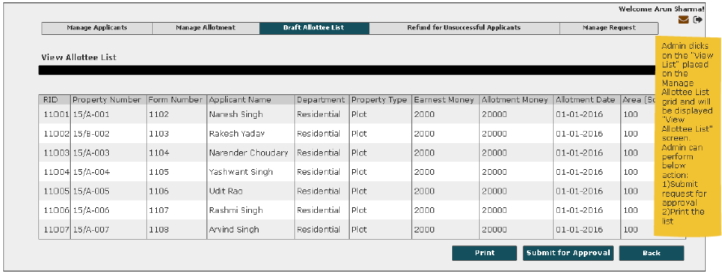 Allottee list not submitted
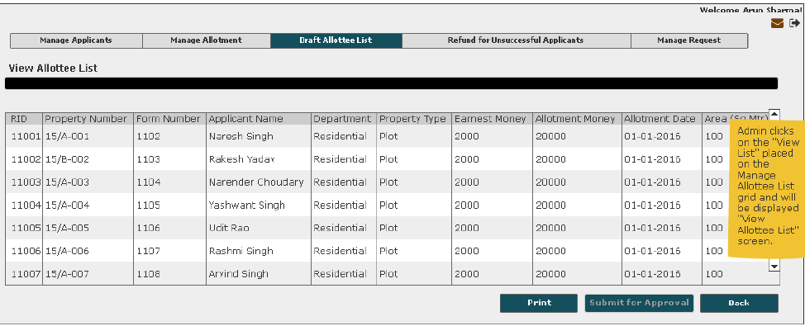
Allottee list submitted for approval
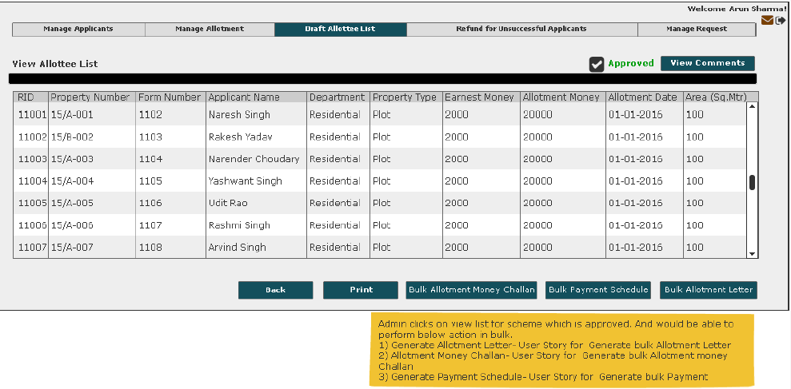
Approved allottee list

User Story- Submit Allottee list for approval

Sprint | 3
User Story ID | 011
User Story Title | Submit allottee list for approval
Actors | Department user
Story | As a department user, I want to submit an allottee list for approval to get property allotment approved.
Pre Conditions | - User should have required access rights.
Business Criteria | - Allottee list should be visible department wise for each scheme, user can only see entries for his departments  - If an allottee list has been rejected then user would receive a notification for the same.  - Auto notifications will be sent to approver with an interval of 3 days, if an allottee list is pending for approval for more than 3 days.  - User can resubmit rejected list for approval.  - Only those users should be visible for approval who had approval rights.
Acceptance Criteria | Navigation: Draft Allottee List -> view list -> ‘Submit for Approval’  - User would click on ‘Submit for Approval’ button.  - User would get a popup to select approver name, user would select desired name and click on ‘Submit’ button.  - Allottee list will be submitted for approval and control will directed to draft allottee list screen.  - An automatic notification will be sent to approver stating “Allottee list for ‘Scheme Name’ has been submitted for approval by ‘username’”.  - Status of the allottee list will be changed to in progress in the grid on draft allottee list screen.
Field level Validation

Mock-ups
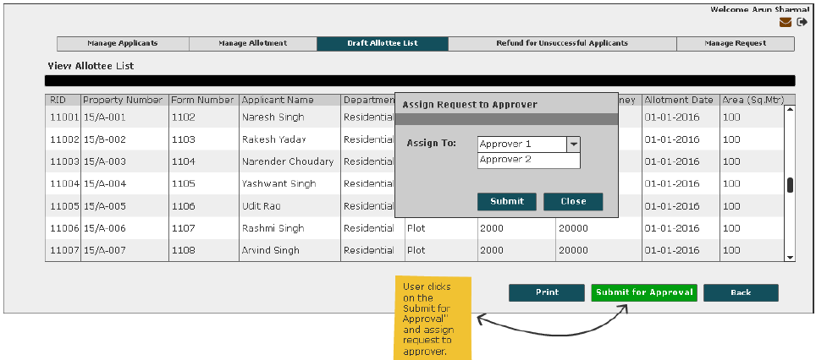

User Story- View Comment

Sprint | 3
User Story ID | 012
User Story Title | View Comment
Actors | Department user
Story | As a department user, I want to view comment on allottee list and unsuccessful applicants list
Pre Conditions | - User should have required access rights.
Business Criteria
Acceptance Criteria | Navigation:  - Draft Allottee List -> View list -> View Comment  - Refunds for Unsuccessful Applicants-> View list -> View Comment  - User would see a Popup window with the following information:  - Comment from  - Comment  - Comment Date  - If user needs to go back or cancel this screen, user would click on ‘Close’ button and the control will be directed to Draft allottee list screen or ‘Refunds for Unsuccessful Applicants’ screen depending on navigation.
Field level Validation

Mock-ups

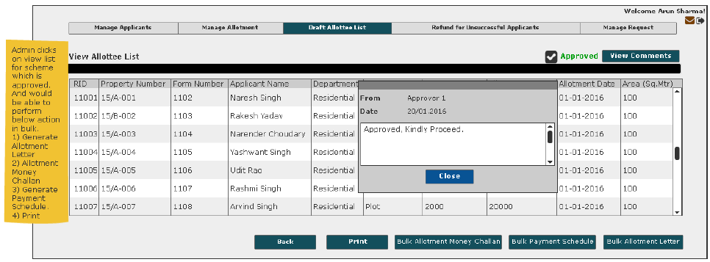
Approved Allottee List
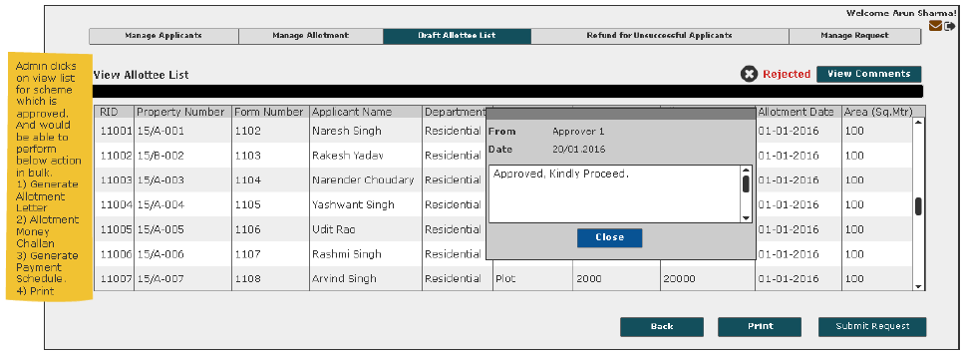
Rejected Allottee List
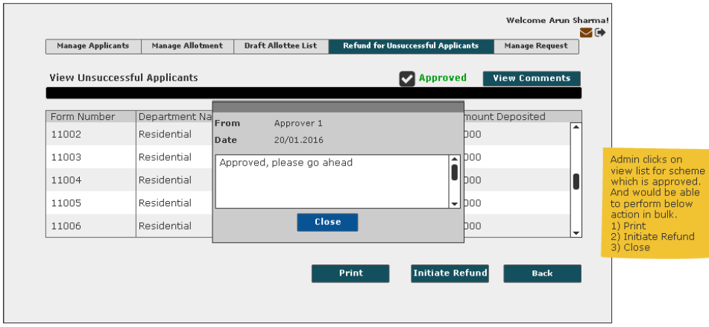
Approved Unsuccessful Applicant List
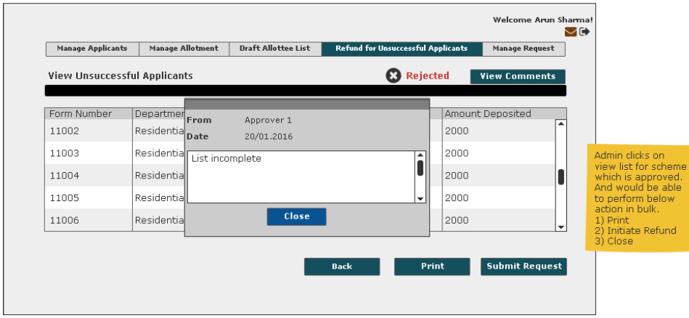
Rejected Unsuccessful Applicant List

User Story- Generate Bulk Allotment Letter

Sprint | 3
User Story ID | 013
User Story Title | Generate Bulk Allotment Letter
Actors | Department user
Story | As a department user, I want system to generate allotment letter in bulk of all properties in an allottee list.
Pre Conditions | - User should have required access rights.  - Allottee List must be approved.
Business Criteria | - Bulk Allotment letter would be generated only for approved allottee lists.
Acceptance Criteria | Navigation: Draft Allottee List -> View List -> ‘Bulk Allotment Letter’  - User would click on ‘Bulk Allotment Letter’ and all allotment letters in this approved allottee list will be generated and displayed on the application screen.  - User would have the options to save the file to his local system by clicking on ‘Save’ button or print all allotment letters by clicking on ‘Print’ button.  - User can close this screen without making any changes by clicking on ‘Close’ button and the flow will return on the View list screen.
Field level Validation

Mock-ups
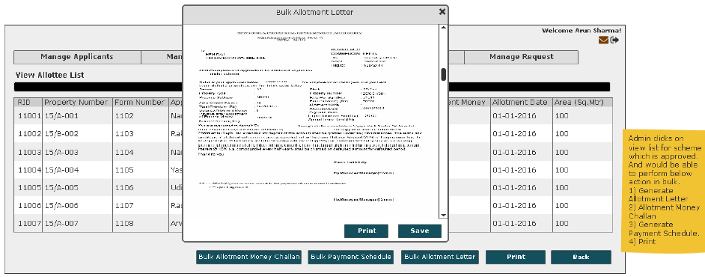

User Story- Generate Bulk Payment Schedule

Sprint | 3
User Story ID | 014
User Story Title | Generate Bulk Payment Schedule
Actors | Department user
Story | As a department user, I want system to generate payment schedule in bulk of all properties in an allottee list to the customer
Pre Conditions | - User should have required access rights.  - Allottee List must be approved.
Business Criteria | - Bulk Payment schedule would be generated only for approved allottee lists.  - For 'Housing' and 'Industrial' department payment schedule is created on equated monthly basis.  - For 'Residential', 'Commercial’, 'institutional' and 'Group Housing' department payment schedule is created on reducing monthly basis.  - Frequency of installment would be yearly (1), half yearly (2), Quarterly (4), Monthly (12).  Payment Schedule- Reducing Monthly installments ( for detailed description please refer to Excel Sheet)  Total Premium Balance Amount = Total Cost of property – (allotment money + earnest money)  Principal Amount= Total Premium Balance Amount/No. of Installments  First Installment Interest Calculation = [Total Premium Balance Amount * (Rate of Interest/Frequency)]/100  The first installment in reducing monthly installment method can be calculated as:  Premium Balance Amount = Premium Balance Amount - First Installment Principal Amount  From First Installment Interest onwards,  Second Installment Interest Calculation = [Balance Premium Amount *(Rate of interest/Frequency)]/100  Premium Balance Amount = Premium Balance Amount - Second Installment Principal Amount  Similarly,  Nth Installment Interest Calculation = [Balance Premium Amount *(Rate of Interest/Frequency)]/100  Premium Balance Amount = Premium Balance Amount - nth Installment Principal Amount  Payment Schedule- Equated Monthly Installments (for detailed description please refer to Excel Sheet)  Rate of Interest, r = (N.I. / (12/f))  Where, F=frequency;=1(yearly),f=2(halfyearly),f=4(quarterly),f=12(monthly)  N.I. = Normal Interest  n = Number of installment  The factor can be calculated as  Factor, F = [POW ((1+r/100), n) * r/100] / [POW ((1+r/100), n)-1]  So, the installment amount can be calculated as the product of Balance Amount and the Factor (calculated using the above formula), i.e.:  Installment Amount = Balance Amount * Factor  Calculate outstanding payment at any point of time against a payment schedule  Dues are calculated e.g., if an instalment is missed, it is marked as dues. Penal interest is applicable on dues  In case customer pay partial amount before due date of next instalment then, reconciliation takes place and penal interest is applicable  - Till date on the amount dues.  - Up to the due date for next instalment, on dues remaining (dues minus partial payment)  In case customer pays amount on due date then reconciliation takes place on due date.  Penal Interest = P*(1+r/100) ^ n  Where,  P = Principal  r = rate of interest  n = frequency
Acceptance Criteria | Navigation: Draft Allottee List -> View List -> ‘Bulk Payment Schedule’  - User would click on ‘Bulk Payment Schedule’ and all payment schedules in the approved allottee list will be generated and displayed on the application screen.  - User would have the options to save the file to his local system by clicking on ‘Save’ button or print all payment schedules by clicking on ‘Print’ button.
Field level Validation

Mock-ups
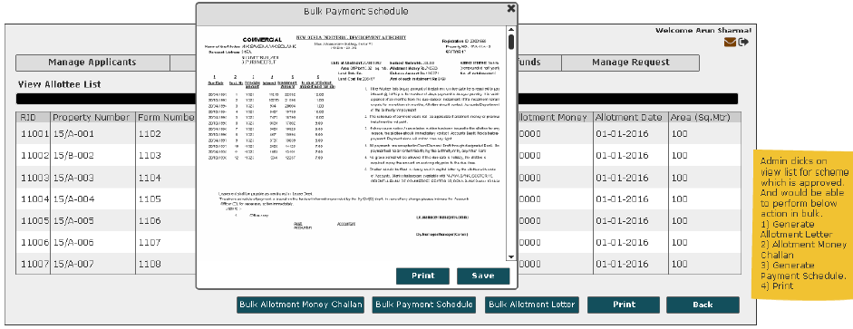

User Story- Generate Bulk Allotment Money Challan

Sprint | 3
User Story ID | 015
User Story Title | Generate Bulk Allotment Money Challan
Actors | Department user
Story | As a department user, I want system to generate allotment letter in bulk of all properties in an allottee list to the customer.
Pre Conditions | - User should have required access rights.  - Allottee List must be approved.
Business Criteria | - Bulk Allotment Money Challan would be generated only for approved allottee lists.
Acceptance Criteria | Navigation:Draft Allottee List -> View List -> ‘Bulk Allotment Letter’  - User would click on ‘Bulk Allotment Money Challan’ and all allotment money challan in the approved allottee list will be generated and displayed on the application screen.  - User would have the options to save the file to his local system by clicking on ‘Save’ button or print all allotment money challans by clicking on ‘Print’ button.
Field level Validation

Mock-ups
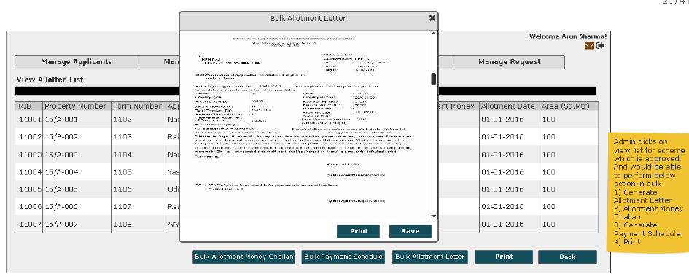

User Story- Generate an Allotment Letter

Sprint | 3
User Story ID | 016
User Story Title | Generate an Allotment Letter
Actors | Department user
Story | As a department user, I want system to generate an allotment letter to the customer.
Pre Conditions | - User should have required access rights.  - Allotment should be approved.
Business Criteria | - Allotment letter would be generated only for approved allotment of property.
Acceptance Criteria | Navigation: Manage Allotment -> View -> ‘Allotment Letter’  - User would click on ‘Allotment Letter’ and allotment letter for the approved allotment would be generated and displayed on the application screen.  - User would have the options to save the file to his local system by clicking on ‘Save’ button or print allotment letter by clicking on ‘Print’ button.  - User can close this screen without making any changes by clicking on ‘Close’ button and the flow will return on the View allotment screen.
Field level Validation

Mock-ups

User Story- Generate a Payment Schedule

Sprint | 3
User Story ID | 017
User Story Title | Generate a Payment Schedule
Actors | Department user
Story | As a department user, I want system to generate a payment schedule to the customer
Pre Conditions | - User should have required access rights.  - Allotment should be approved.
Business Criteria | - Payment Schedule would be generated only for approved allotment of property.  - For 'Housing' and 'Industrial' department payment schedule is created on equated monthly basis.  - For 'Residential', 'Commercial’, 'institutional' and 'Group Housing' department payment schedule is created on reducing monthly basis.  - Frequency of installment would be yearly (1), half yearly (2), Quarterly (4), Monthly (12).  Payment Schedule- Reducing Monthly installments (for detailed description please refer to Excel Sheet)  Total Premium Balance Amount = Total Cost of property – (allotment money + earnest money)  Principal Amount= Total Premium Balance Amount/No. of Installments  First Installment Interest Calculation = [Total Premium Balance Amount * (Rate of Interest/Frequency)]/100  The first installment in reducing monthly installment method can be calculated as:  Premium Balance Amount = Premium Balance Amount - First Installment Principal Amount  From First Installment Interest onwards,  Second Installment Interest Calculation = [Balance Premium Amount *(Rate of interest/Frequency)]/100  Premium Balance Amount = Premium Balance Amount - Second Installment Principal Amount  Similarly,  Nth Installment Interest Calculation = [Balance Premium Amount *(Rate of Interest/Frequency)]/100  Premium Balance Amount = Premium Balance Amount - nth Installment Principal Amount  Payment Schedule- Equated Monthly Installments (for detailed description please refer to Excel Sheet)  Rate of Interest, r = (N.I. / (12/f))  Where, F=frequency;=1(yearly),f=2(halfyearly),f=4(quarterly),f=12(monthly)  N.I. = Normal Interest  n = Number of installment  The factor can be calculated as  Factor, F = [POW ((1+r/100), n) * r/100] / [POW ((1+r/100), n)-1]  So, the installment amount can be calculated as the product of Balance Amount and the Factor (calculated using the above formula), i.e.:  Installment Amount = Balance Amount * Factor  Calculate outstanding payment at any point of time against a payment schedule  Dues are calculated e.g., if an instalment is missed, it is marked as dues. Penal interest is applicable on dues  In case customer pay partial amount before due date of next instalment then, reconciliation takes place and penal interest is applicable  - Till date on the amount dues.  - Up to the due date for next instalment, on dues remaining (dues minus partial payment)  In case customer pays amount on due date then reconciliation takes place on due date.  Penal Interest = P*(1+r/100) ^ n  Where,  P = Principal  r = rate of interest  n = frequency
Acceptance Criteria | Navigation: Manage Allotment -> View -> ‘Payment Schedule’  - User would click on ‘Payment Schedule’ and payment schedule for the approved allotment would be generated and displayed on the application screen.  - User would have the options to save the file to his local system by clicking on ‘Save’ button or print payment schedule by clicking on ‘Print’ button.
Field level Validation

Mock-ups
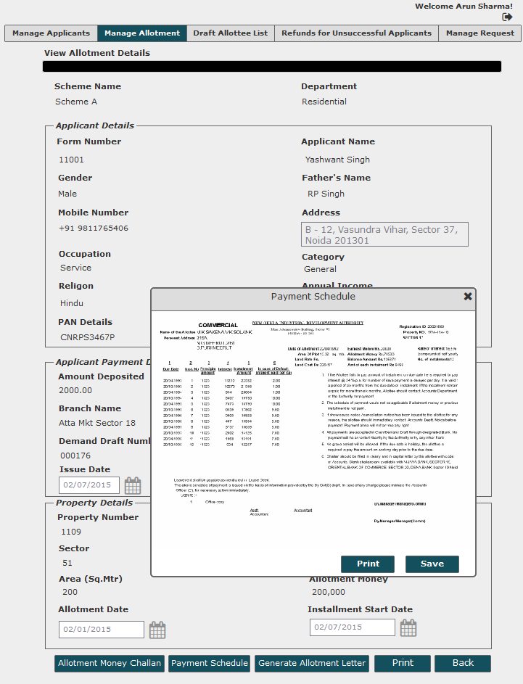

User Story- Generate an Allotment Money Challan

Sprint | 3
User Story ID | 018
User Story Title | Generate an Allotment Money Challan
Actors | Department user
Story | As a department user, I want system to generate an allotment letter to the customer.
Pre Conditions | - User should have required access rights.  - Allotment must be approved.
Business Criteria | - Allotment Money Challan would be generated only for approved allotment of property.
Acceptance Criteria | Navigation: Manage Allotment -> View -> ‘Allotment Letter’  - User would click on ‘Allotment Money Challan’ and allotment money challan for approved allotment would be generated and displayed on the application screen.  - User would have the options to save the file to his local system by clicking on ‘Save’ button or print allotment money challan by clicking on ‘Print’ button.
Field level Validation

Mock-ups

User Story- Create unsuccessful applicant list

Sprint | 3
User Story ID | 019
User Story Title | Create unsuccessful applicant list
Actors | Department user
Story | As a department user, I want system to create unsuccessful applicant list of a scheme based on allotment details.
Pre Conditions | - User should have required access rights.
Business Criteria | - Unsuccessful applicant list would be created by system based on allotment entry.  - List should be visible department wise for each scheme, user can only see entries for his departments
Acceptance Criteria | - User would click on ‘Refunds for Unsuccessful Applicants’ menu and get a grid which contain scheme wise unsuccessful applicant list details, this will be created by system, based on the allotment entry data. For each list, grid will contain following columns:  - Scheme Name  - Department  - Refund Status, Values  - Not submitted: If list not submitted for approval  - In progress: If list is submitted but not approved from approver side.  - Approved: If list is approved by approver  - Refund Initiated: If refund initiated for approved list  - Reject: If list is rejected by approver.  - Submitted Date (blank if not submitted)  - Refund initiate Date (for refund initiated)  - Actions- ‘View List’
Field level Validation

Mock-ups

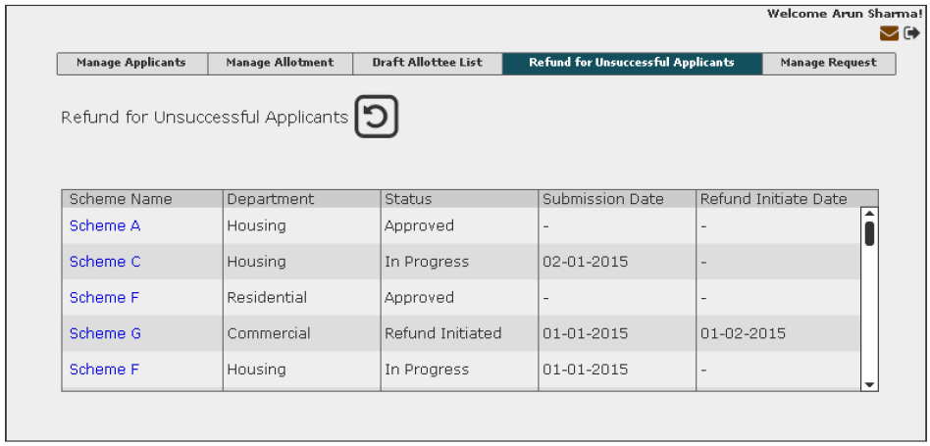

User Story- View Unsuccessful Applicant List

Sprint | 3
User Story ID | 020
User Story Title | View unsuccessful Applicant Lists
Actors | Department user
Story | As a department user, I want to view unsuccessful applicant list so that I can submit it for approval to initiate refund.
Pre Conditions | - User should have required access rights.
Business Criteria | - List should be visible department wise for each scheme, user can only see entries for his departments  - If list is not submitted for approval, user would get ‘Submit for approval’ button along with ‘Print’ and ‘Close’ button.  - If list is submitted for approval but not approved yet user would get ‘Submit for Approval’ button grayed out along with ‘print’ and ‘close’ button.  - If list is approved, then user would get following buttons:  - Initiate refund  - View Comment  - Print  - Close  - If an approved list is initiated for refund then user would get the Initiate refund button grayed out along with ‘View Comment’, ‘Print’ and ‘close’ button
Acceptance Criteria | - User would click on Scheme Name available in grid against each list on ‘Refunds for Unsuccessful Applicants’ screen.  - User would get the list with the following columns:  - Form no.  - Department  - Applicant Name  - Mobile  - Amount Deposited  - Along with the list, user would get following buttons based on scenarios(business rules):  - Submit for Approval  - Initiate refund  - View Comment  - Print  - Close
Field level Validation

Mock-ups
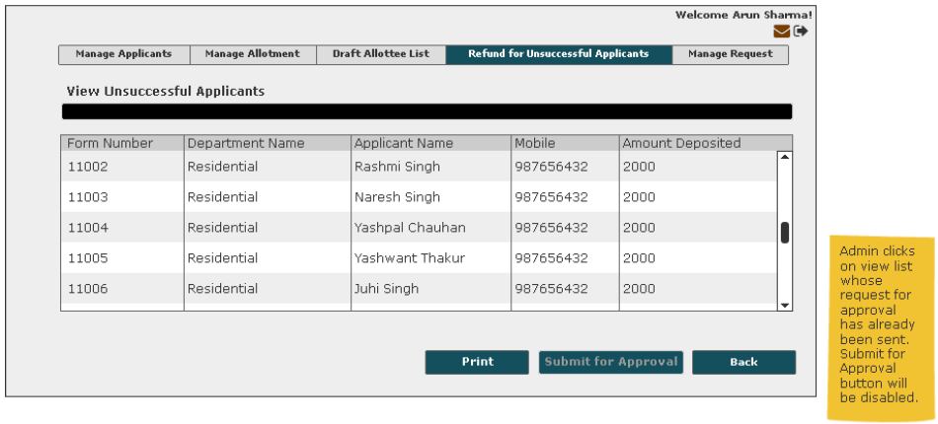

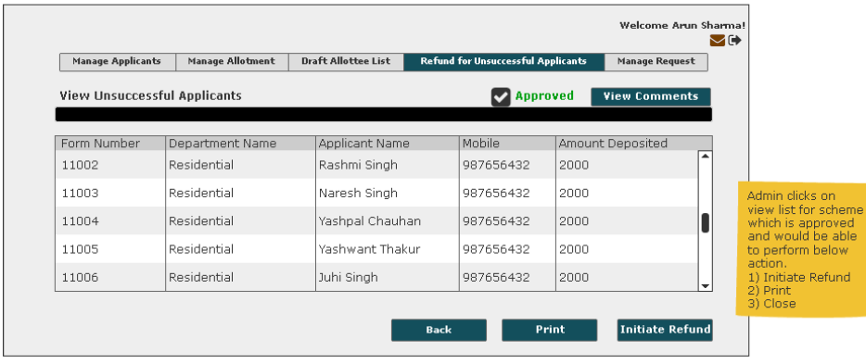
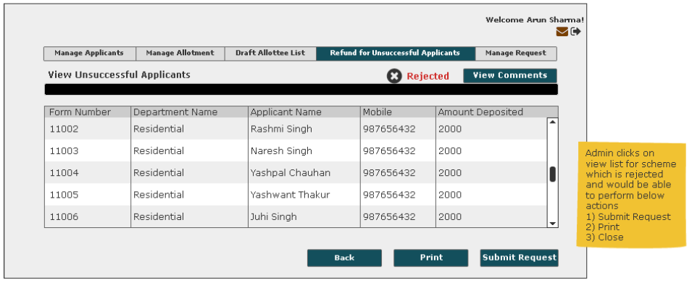

User Story- Submit unsuccessful candidate list for approval

Sprint | 3
User Story ID | 021
User Story Title | Submit allottee list for approval
Actors | Department user
Story | As a department user, I want to submit unsuccessful applicant list for approval so that I can initiate refund.
Pre Conditions | - User should have required access rights.
Business Criteria | - List should be visible department wise for each scheme, user can only see entries for his departments  - If a list has been rejected, then user would receive a notification for the same.  - Auto notifications will be sent to approver with an interval of 3 days, if a list is in progress for approval for more than 3 days.  - User can resubmit rejected list for approval.  - Only those users should be visible for approval who had approval rights.
Acceptance Criteria | Navigation: Refunds for Unsuccessful Applicants -> view list -> ‘Submit for Approval’  - User would click on ‘Submit for Approval’ button.  - User would get a popup to select approver name, user would select desired name and click on ‘Submit’ button.  - List will be submitted for approval and control will directed to ‘Refunds for Unsuccessful Applicants’ screen.  - An automatic notification will be sent to approver stating “Unsuccessful applicant list for ‘Scheme Name’ has been submitted for approval by ‘username’”.  - Status of the list will be changed to in progress in the grid on Draft allottee list screen.
Field level Validation

Mock-ups

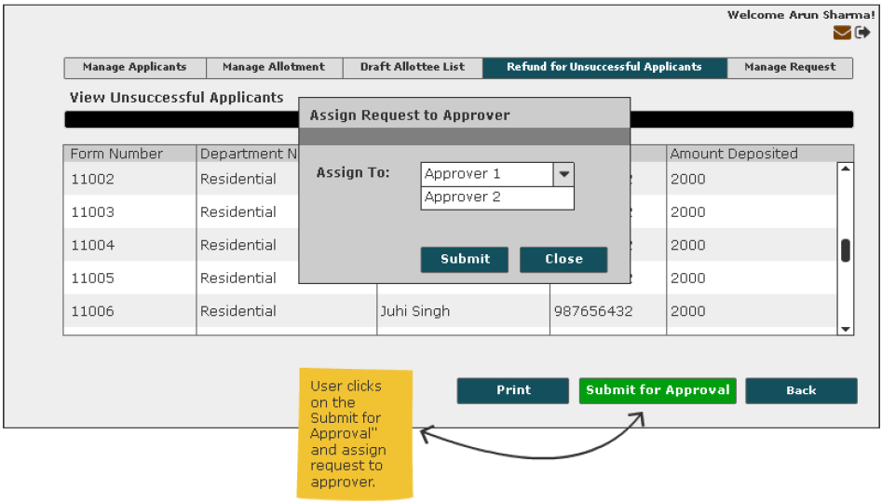

User Story- Initiate Refund for Unsuccessful Applicants

Sprint | 3
User Story ID | 022
User Story Title | Initiate Refund for unsuccessful applicants
Actors | Department user
` | As a department user, I want to initiate refunds for unsuccessful applicants
Pre Conditions | - User should have required access rights.  - User should not have any allotted property.
Business Criteria | - Refund would be initiated only for approved lists.  - Email would be sent to accounts department which contain list of unsuccessful applicants in pdf format.
Acceptance Criteria | Navigation: Refunds for Unsuccessful Applicants -> view list -> ‘Initiate Refund’  - User would click on ‘Initiate Refunds’ button and an email notification would be sent to accounts department for initiating refund for unsuccessful applicants.  - Email would also contain List in PDF format.
Field level Validation

Mock-ups

User Story- Approve/Reject request

Sprint | 3
User Story ID | 023
User Story Title | Approve/Reject request
Actors | Department user
` | As a department user, I want to approve/reject request
Pre Conditions | - User should have required access rights.  - User should not have any allotted property.
Business Criteria | - It is mandatory to provide a comment for rejecting a list.  - Once a request is approved/rejected a notification would be send to initiator of the request.  - Once, allottee list is approved, payment schedule for each allotment entry would be created in the database
Acceptance Criteria | Navigation: 1) Manage Request -> Allottee lists -> Scheme Name  2) Manage Request -> Unsuccessful Applicants List -> Scheme Name  - Under User would click on ‘Approve’ button to approve the list or ‘Reject’ button to reject the list.  - In both cases user would get a popup window to provide comment.  - In case of ‘Approve’ user would have a choice to provide comment or not however, in case of ‘Reject’ it is mandatory to provide comment.
Field level Validation | - Comment: Text, maximum 500 characters, mandatory in case of reject list.

Mock-ups

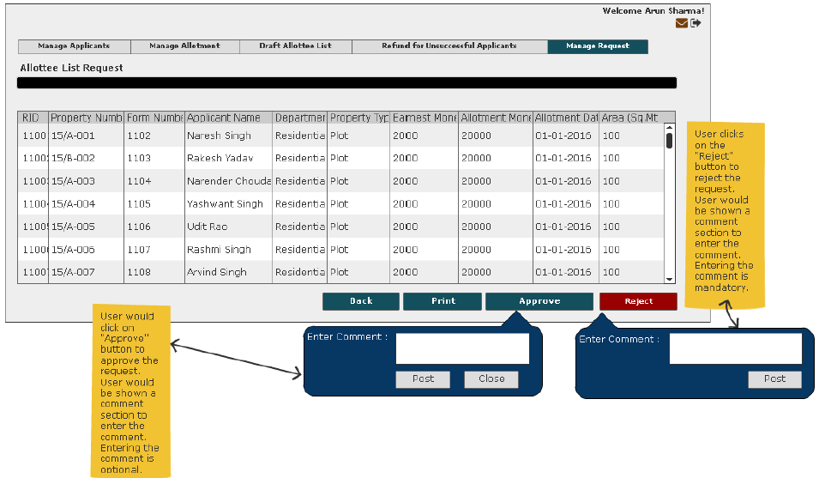
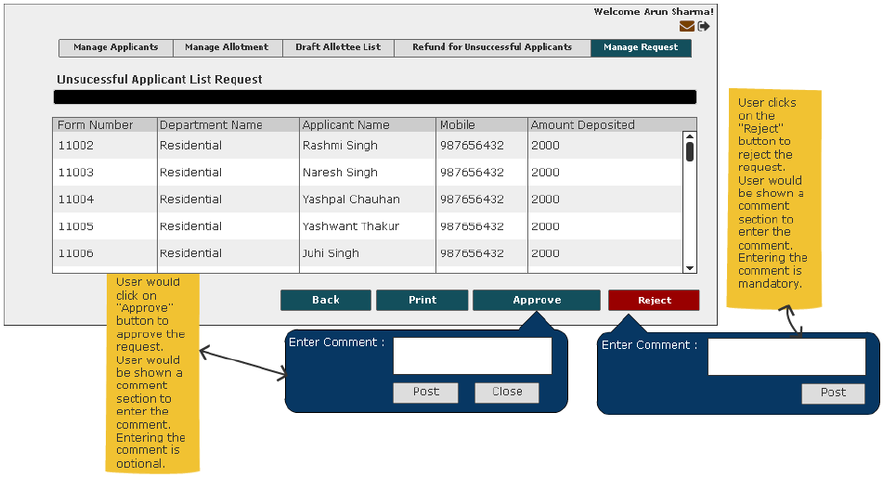

User Story- View Allottee List for approver

Sprint | 3
User Story ID | 024
User Story Title | View Allottee Lists
Actors | Approver
Story | As an approver, I want to view allottee list.
Pre Conditions | - User should have required access rights.
Business Criteria | - If List is not approved/rejected user would get ‘Approved’ and ‘Reject’ button along with ‘View Comment’, ‘Print’ and ‘Close’ button.  - If list is approved, approver would get ‘View Comment’, ‘Print’ and ‘Close’ button.  - If list is rejected, approver would get ‘View Comment’, ‘Approve’, and ‘Print’ button along with ‘Close’ button.
Acceptance Criteria | Navigation: Manage Requests -> Allottee list -> Scheme Name  - User would get the allottee list with the following columns:  - Property no  - Form no.  - Applicant Name  - Department  - Property Type  - Sector  - Block  - Area  - Along with the list, user would get following buttons based on scenarios (business rules):  - Approve  - Reject  - View Comment  - Print  - Close
Field level Validation

Mock-ups

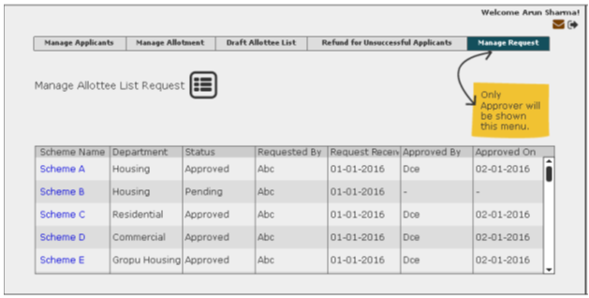
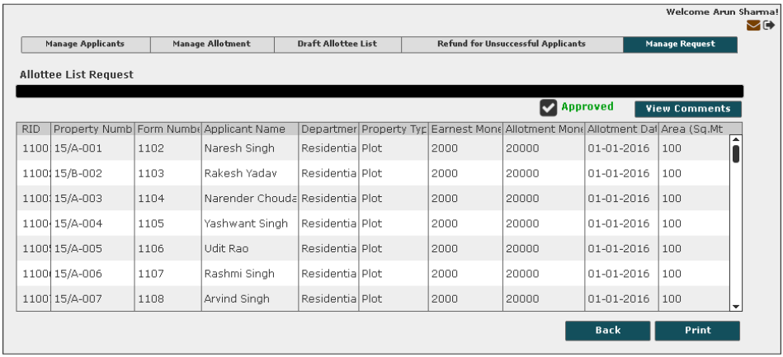
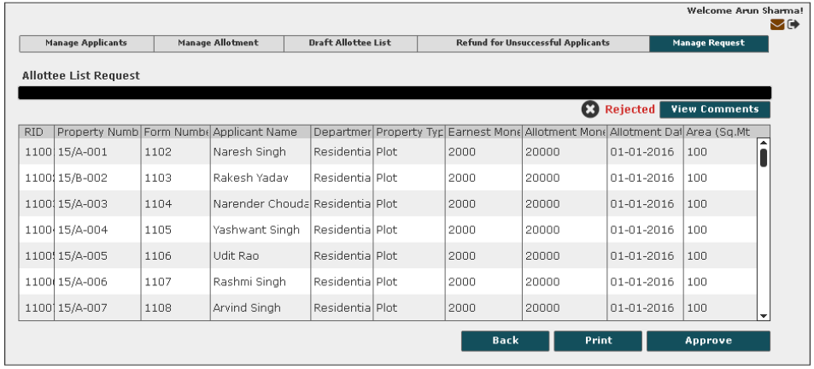

User Story- View Unsuccessful Applicant list for approver

Sprint | 3
User Story ID | 025
User Story Title | View unsuccessful application
Actors | Approver
Story | As an approver, I want to view unsuccessful applicant list.
Pre Conditions | - User should have required access rights.
Business Criteria | - If List is not approved/rejected user would get ‘Approved’ and ‘Reject’ button along with ‘View Comment’, ‘Print’ and ‘Close’ button.  - If list is approved, approver would get ‘View Comment’, ‘Print’ and ‘Close’ button.  - If list is rejected, approver would get ‘View Comment’, ‘Approve’, and ‘Print’ button along with ‘Close’ button.
Acceptance Criteria | Navigation: Manage Requests ->unsuccessful applicant list -> View List  - User would get the allottee list with the following columns:  - Form no.  - Department  - Applicant Name  - Mobile  - Amount Deposited  - Along with the list, user would get following buttons based on scenarios (business rules):  - Approve  - Reject  - View Comment  - Print  - Close
Field level Validation

Mock-ups

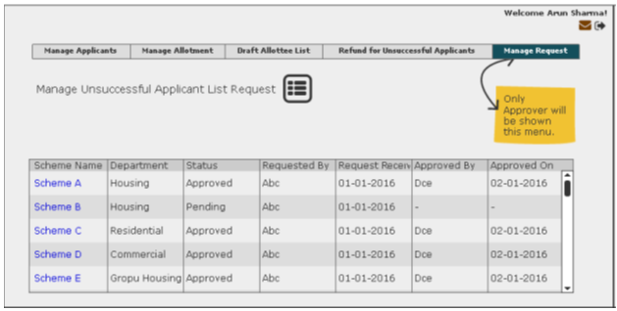
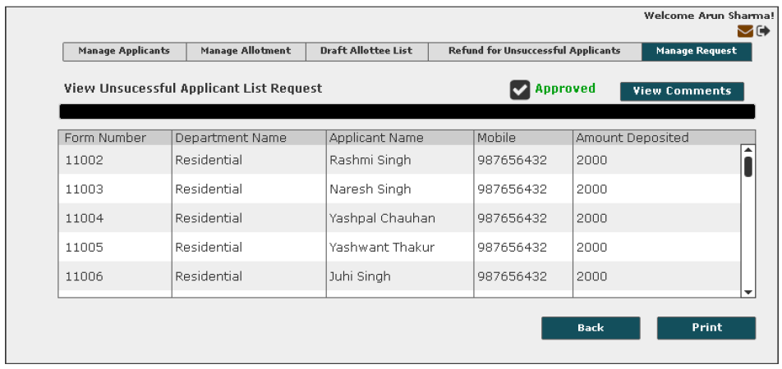
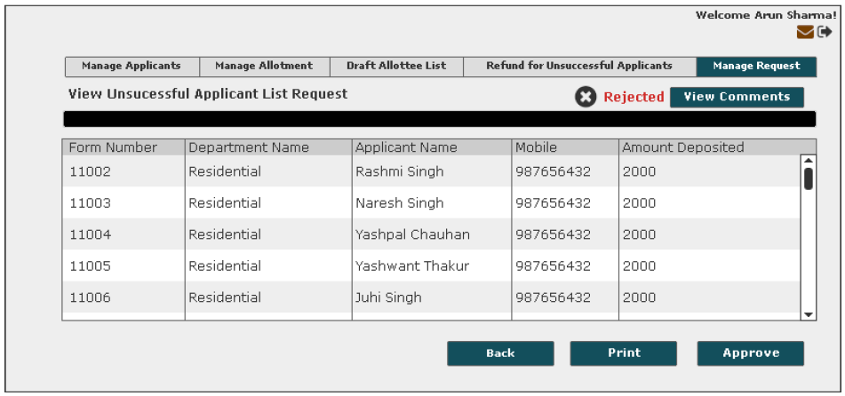

User Story- View Comment- Approver

Sprint | 3
User Story ID | 026
User Story Title | View Comment
Actors | Approver
Story | As an approver, I want to view comment on allottee list and unsuccessful applicants list
Pre Conditions | - User should have required access rights.
Business Criteria | - Option would be available for approved/rejected list only.
Acceptance Criteria | Navigation:  - Manage requests -> Allottee List -> View comment  - Manage Requests -> Unsuccessful Applicants list -> View comment  - User would see a Popup window with the following information:  - Comment from  - Comment  - Comment Date  - If user needs to go back or cancel this screen, user would click on ‘Close’ button and the control will be directed to Draft allottee list screen or ‘Refunds for Unsuccessful Applicants’ screen depending on navigation.

Mock-ups
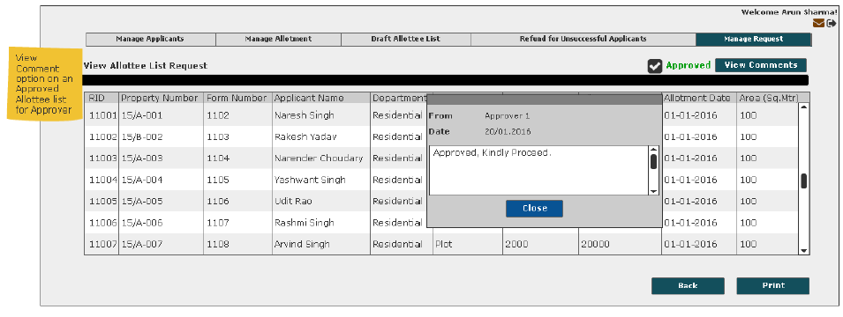
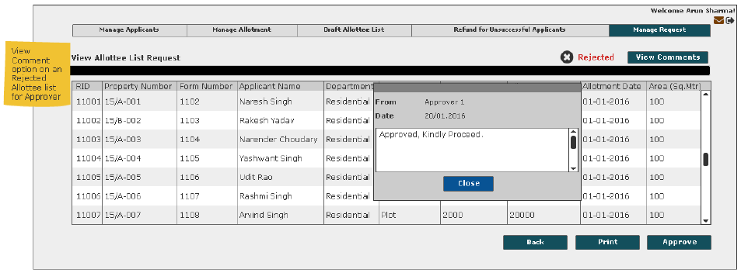

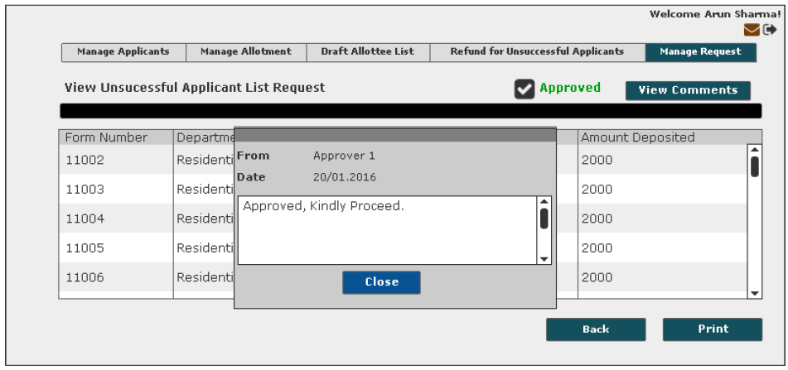

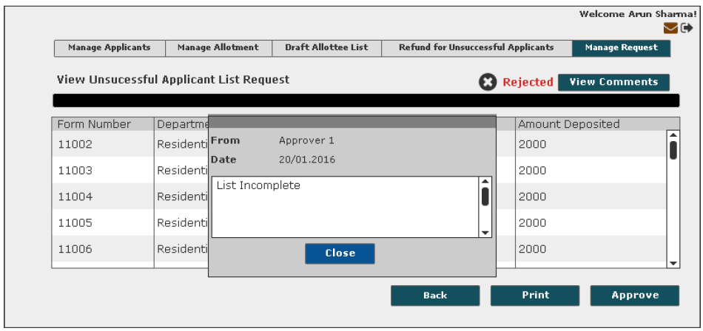

User Story- Update Personal Information

Sprint | 3
User Story ID | 027
User Story Title | Update personal Information
Actors | Department User
Story | As an approver, I want to update personal information of allottees.
Pre Conditions | - User should have required access rights.
Business Criteria | - Update personal information would be available for allottees only.
Acceptance Criteria | - User would click on ‘Update Personal Information’ Button under manage application menu.  - User would see a form with the following fields:  - RID : drop down, mandatory  - Permanent Address: Textbox  - Correspondence Address: Textbox  - Mobile Number: Textbox (Numeric)  - Phone Number: Textbox (part1: STD, part2: number)  - FAX number: Textbox (part1: STD , part2: number)  - Email: Textbox  - Once user selects an RID, above fields with existing data would be displayed except request number, user would edit the information as per request and provide a request no for this change.  - User would click on ‘Submit’ button and information would be updated.
Field Level Validations | - Permanent Address: Text with numbers and special characters, maximum 500 characters.  - Correspondence Address: Text with numbers and special characters, maximum 500 characters.  - Mobile Number:  - Maximum 12 digits, can’t be zero  - Phone Number:  - Part 1: numeric, maximum 8 digits, can’t be zero  - Part 2: numeric, maximum 12 digits, minimum 8 digits, can’t be zero  - FAX Number:  - Part 1: numeric, maximum 8 digits, can’t be zero  - Part 2: numeric, maximum 12 digits, minimum 8 digits, can’t be zero  - Email: Text with numbers and special characters, maximum 100 characters, validate against email format (abc@xyz.com).

Mock-ups
